CSA0510 – DATABASE MANAGEMENT SYSTEM
LAB EXPERINMENT 12

Simple Programming using REPEAT, WHILE

Aim:
To learn how to use various MySQL loop statements including while, repeat to run a block of code repeatedly based on a condition.
WHILE loop Syntax:

WHILE expression
DOstatements
END WHILE;

Procedure:
- The WHILE loop checks the expression at the beginning of each iteration.
- If the expression valuates to TRUE, MySQL will execute statements between WHILE and END WHILE until the expression evaluates to FALSE.
- The WHILE loop is called pretest loop because it checks the expression before the statements execute.

The following flowchart illustrates the WHILE loop statement:

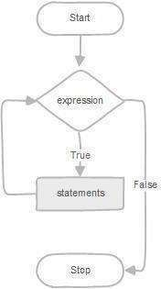
REPEAT loop Syntax:

REPEATstatements
UNTIL expression
END REPEAT;

Procedure:
- First, MySQL executes the statements, and then it evaluates the expression.
- Ifthe expression evaluates to FALSE, MySQL executes the statements repeatedly untilthe expression evaluates to TRUE.
- Because the REPEAT loop statement checks the expression after the execution of statements, the REPEAT loop statement is also known as the post-test loop.

The following flowchart illustrates the REPEAT loop statement:

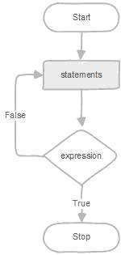

Program-1:
Write a function that uses WHILE statement to build a string repeatedly until the value of the variable becomes x greater than 5. Then, we display the final string using a SELECT statement.
Program-2:
Write a function that uses REPEAT statement which would repeat the loop until income is greater than or equal to 4000, at which point the REPEAT loop would be terminated.

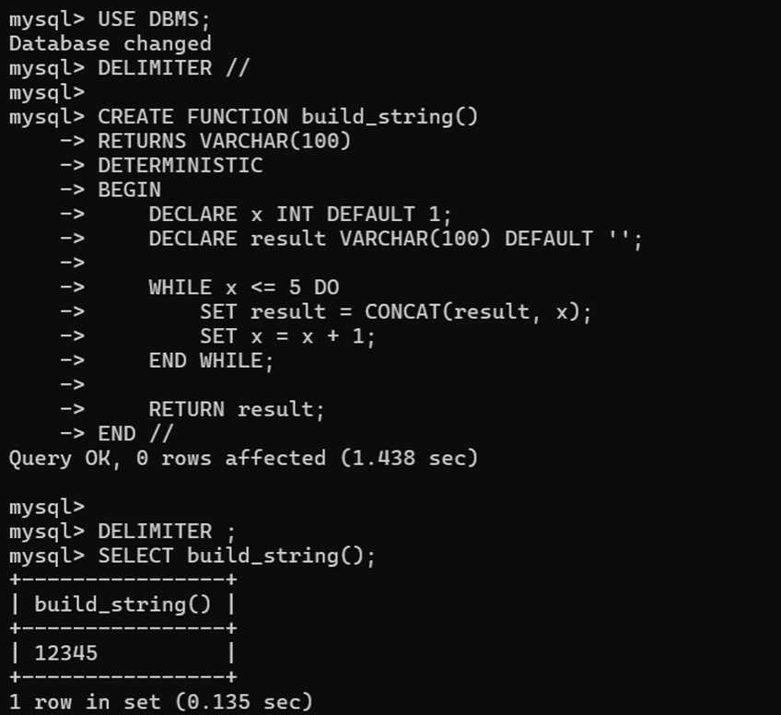
Program 1

Program-2:
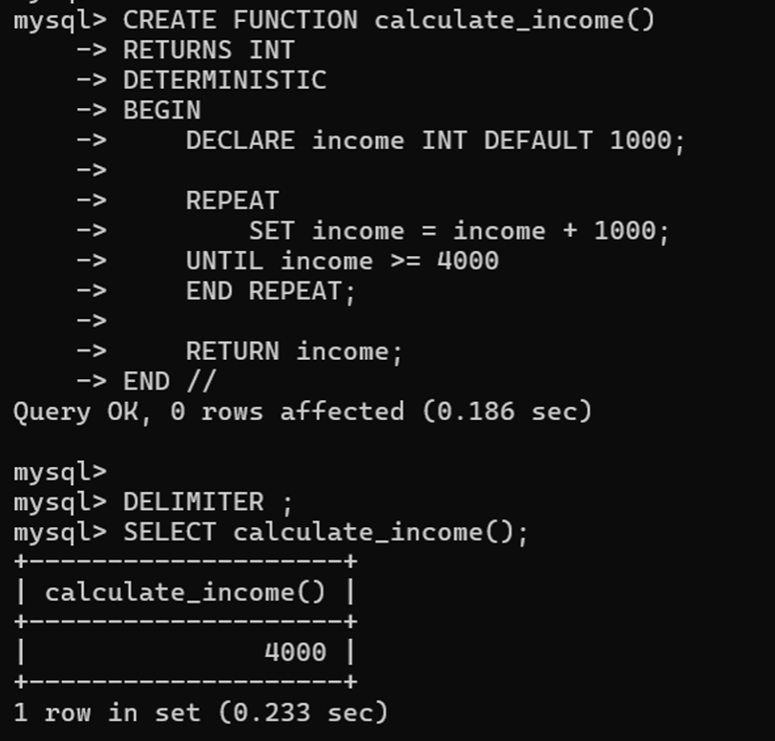

RESULT: Thus the Simple programming exercise using (REPEAT, WHILE )executed successfully.

